Documentation
Team name
28.05.2024
Important Notes:
- The descriptions in italics in this document (except for some section headings) are exemplary and explanatory and must be removed from the completed report.
- Identify which section of this report was created by which team member
- Your documentation should have ca. 8 pages.

Team members
Andrew Antwan
David Gonzalez
Shahzaib Waseem

Introduction

Internet of Things
The internet of things (IoT) consist to connect everyday objects to the internet, which can collect and share the data by utilizing the environment in which they are working. Our project implements devices such as Arduino and Raspberry Pi to control a conveyor belt and robotic arm. These devices talk to each other through the internet to make the system work autonomously.

Wireless Sensor Networks
Wireless sensor networks are collections of small sensors that can sense and transmit data wirelessly, such as temperature or object detection. The color sensor and ultrasonic sensor are a part of this network in our project. They transmit data wirelessly (via an Arduino and a Raspberry Pi) to the main controllers. This facilitates wireless monitoring and control of the robotic arm and conveyor belt.

What is the target application of your project?
Our research aims to implement an automated system for sorting small colored cubes in an industrial environment. The cubes are moved by the conveyor belt; when a cube is detected by the ultrasonic sensor, the robotic arm sorts the cube according to its color. This system can help students to understand how industries sort items quickly and efficiently without needing human intervention.

Concept description
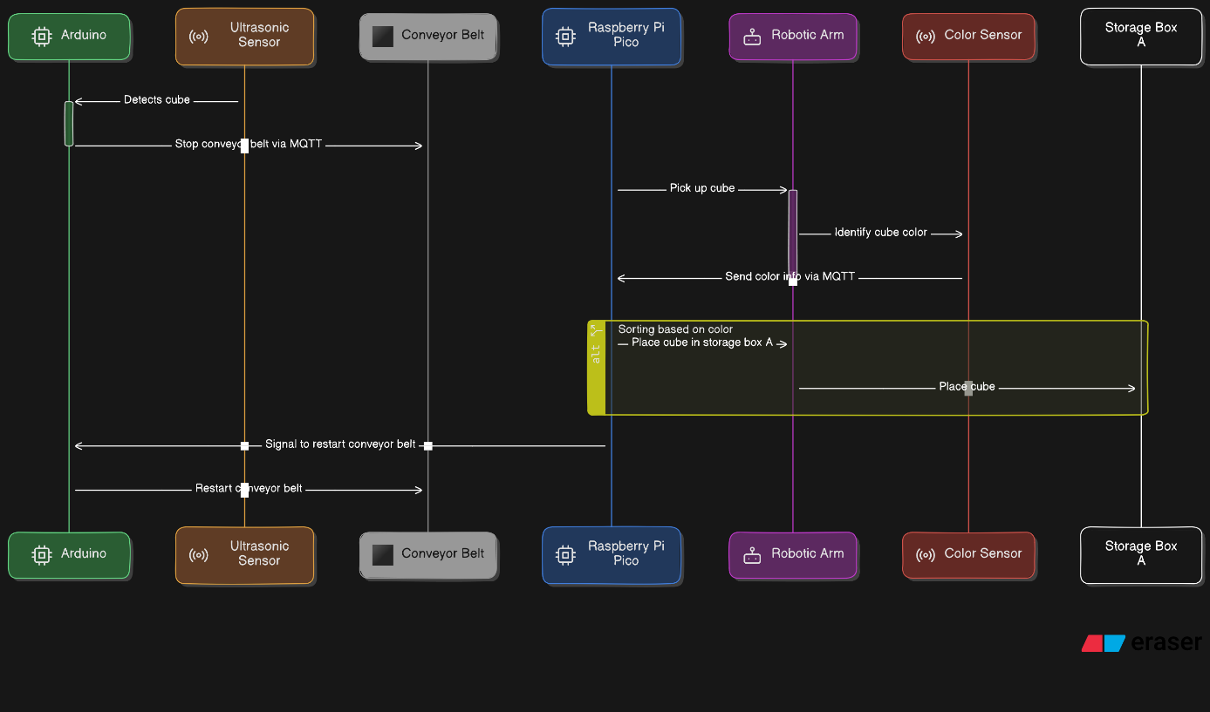
Figure 1 Sequence diagram
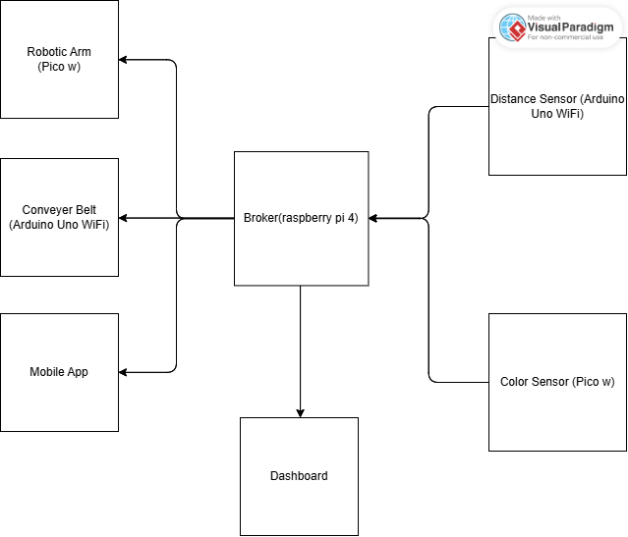
Figure 2 Block Diagram
The project is mainly consisting of 4 components, namely a Color sensor, Robotic Arm, distance sensor and a conveyer belt. The operation starts by the conveyer belt where it runs until the distance sensor detects that a block has reached a specific region. The distance sensor sends a signal to both the conveyer belt in order to stop and to the robotic arm to pick up the block. The robotic arm picks up the block and hovers it over the color sensor where it sends the color detected to the robotic arm where it decides if the color is to be stored in a separate box or returned to the conveyer belt one more time.

Project/Team management
Which project methods you used in your project?
Breakdown: How you managed your tasks?
What are the different tasks/roles of the team members in the project?
Describe which team member did which tasks.

Project Methods
We used mainly GitHub as a common repository for file sharing and to sync up all our work. This allowed us to modify each others work if needed without worrying about overwriting the previous work.

Breakdown
For organizing the work we mainly met 2 times a week. One during the weekends -mainly virtually – to organize tasks and divvy up the work amongst ourselves. This was followed by another meeting in person every Tuesday where we show up the progress on the real hardware and where we would brainstorm ideas if anyone is having problems with their tasks.
We didn’t have a rigid hierarchy in the project, the assignment of tasks is mainly done on a volunteer basis depending on the ability and the vision of each.

Division of tasks
Andrew | David | Shahzaib
Color sensor code | Robotic arm code | Color sensor code
Python MQTT library | Conveyer belt code | Conveyer belt code
Color sensor base 3d design | Robotic Arm 3d design | Arduino MQTT library
Class diagram | Distance sensor 3d design
 | Sequence diagram

Technologies

Arduino Uno Wifi Rev2
The Arduino Uno Wifi Rev2 is used as a constrained device to control both the distance sensor and the conveyer belt. It offers 48 KB of flash memory with 6.144 KB of SRAM, making it a C0 constrained device. It uses the WiFiNINA library to use the Wi-Fi functionality and the ArduinoMqttClient in order to use mqtt functionality.

Raspberry Pi Pico W
The raspberry pi pico w is used to control the color sensor and the robotic arm motors. Both of them communicate over wifi with MQTT protocol using the umqtt simple.py library. It offers stronger specs than the pre-mentioned Arduino uno wifi with 264KB of SRAM and 2MB of flash memory which offers more flexibility which is handy specially that it uses Python which compared to C++ used in Arduino programming can require larger storage space.

Raspberry PI 4
The raspberry pi 4 operates as the central hub that hosts the MQTT broker, sending and receiving all the information from the external nodes

Mosquitto
The nodes all communicate together using the MQTT protocol where nodes as distance sensor and color sensor are publishers of information and nodes as conveyer belt and robotic arm are subscribers. Keeping in mind that some nodes as the robotic arm is both a subscriber and a receiver at the same time. To use the mqtt protocol we are using the Mosquitto client on the raspberry pi 4 which offers easy setup and reliable performance.

Implementation
Describe the static structure of the environment.
Provide a class diagram for this purpose and briefly explain the classes or modules.
Describe the use case(s) of your environment

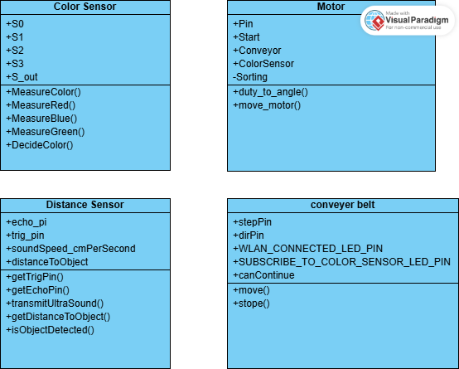Use Case
Give instructions on how to use your application. Potentially using an/more example(s), figures, screenshots etc.

Sources/References
Provide the sources on the technologies and algorithms you used in your project (Github).

